Patient Name | JAIDEV PANDIT | Patient ID | 3460
Age/D.O.B | 71Y | Gender | M
Ref Doctor | SADAR HOSPITAL, DEOGHAR | Date | 4 May 24
MRI Brain Plain and Contrast
History
Loss of memory
Technique
T1W Sagittal, Dw- b0, b500, b1000,
T2W Axial, Flair Coronal.
Post contrast T1FS images
Observations
There is evidence of a ill defined elongated altered signal intensity mass lesion showing lobulated irregular margins involving sub-cortical and peri-ventricular aspect of left temporo-parieto-occipital lobes.
It grossly measures approx. 50 X 35 mm in axial plane and approx. 54 mm in craniocaudal extent.
It appears homogeneously hypo intense on T1W images, heterogeneously hyperintense on T2W and FLAIR images with few small cystic changes within it.
Moderate perilesional edema is noted in form of hyperintense signal on T2W and FLAIR images.
It shows patchy areas of diffusion restriction on DWI/ADC images.
On GRE images, few foci of internal blooming seen- suggest possibility of ? intra-tumoral calcification/ hemorrhage.
Post contrast images show heterogeneous post contrast enhancement with central non enhancing necrotic areas within it.
It causes compression over adjacent left lateral ventricle and minimal midline shift of 3.7 mm towards right side.
Changes of sinusitis are noted in bilateral maxillary sinuses.
On MR spectroscopy study, there is evidence of increase in choline with decreases in NAA and increase in Cho/Cr ratio.
No evidence of abnormal signal intensity or volume loss in the hippocampii.
The thalami, basal ganglia and internal capsules are normal on both sides.
Rest of the ventricles and sulci are normal for the age.
The pituitary gland, infundibulum and hypothalamus are normal for the age.
The posterior fossa shows normal cerebellum.
The medulla, pons and mid brain shows normal signals in all the sequences.
Both CP angles are clear. The basal cisterns are normal.
Normal flow void is seen in the major dural venous sinuses and arteries.
Bones are normal.
Impression
- Above findings are in favor of Neoplastic etiology- High grade Glioma/ Glioblastoma multiforme most likely.
Advice
Histo-pathological correlation.
Key Images
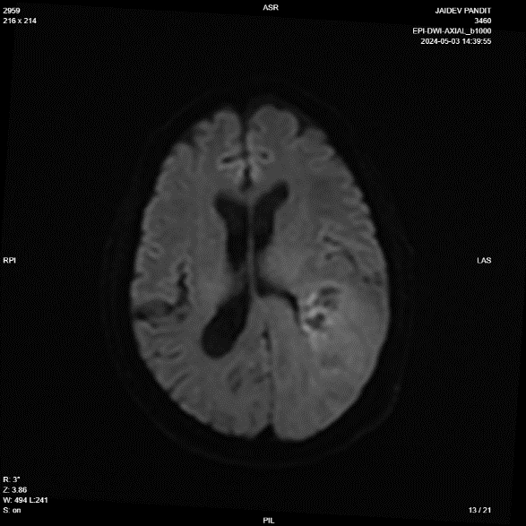
Image 1
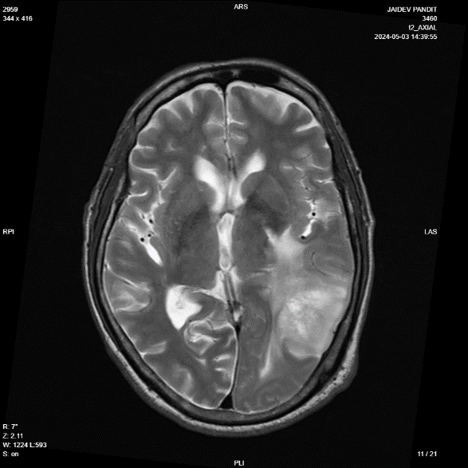
Image 2
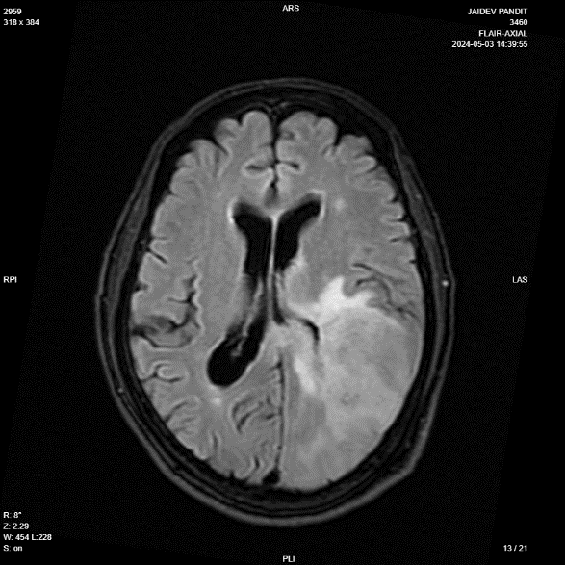
Image 3
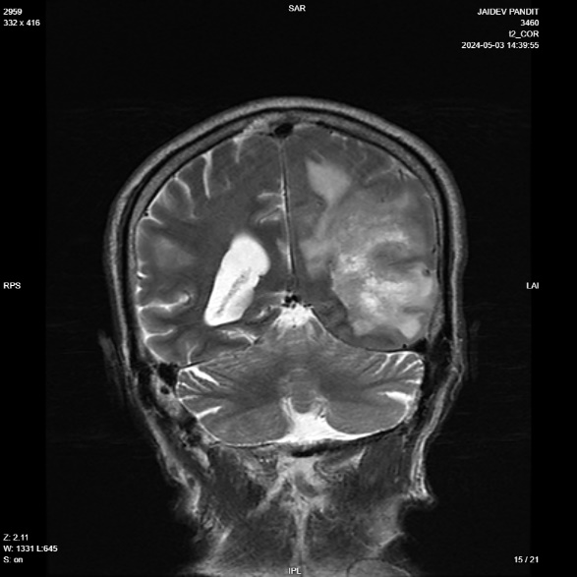
Image 4
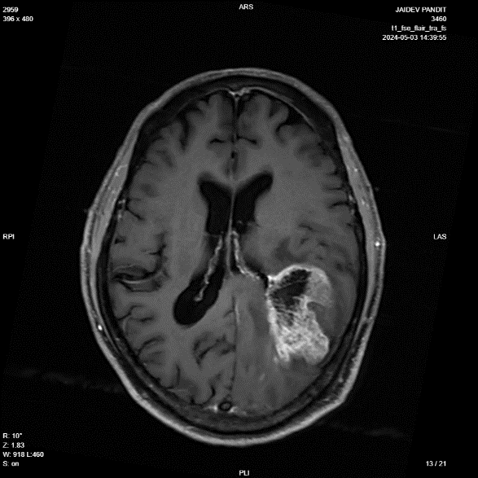
Image 5
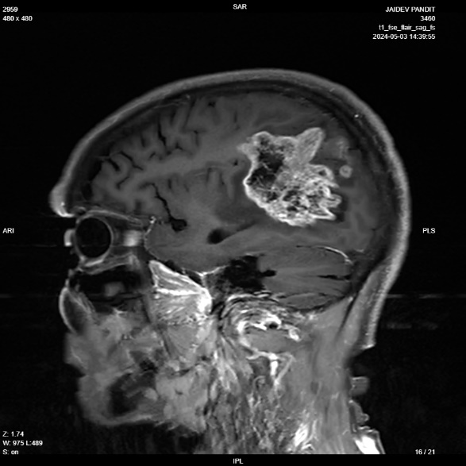
Image 6
Reported By,
Dr. Suthar Mihirkumar Kirtikumar
MBBS, MD
Consultant Radiologist
GMC - G-60699
Disclaimer
This medical diagnostic report is generated based on the image and patient information obtained from the source of origin, 5C Network assumes no responsibility for errors or omission of or in the image, or in the contents of the report, which are a direct interpretation of the image sent from source. In no event shall 5C Network be liable for any special, direct, indirect, consequential, or incidental damages or any damages whatsoever, whether in an action of negligence or other tort, arising out of or in connection with the use of the 5C Network Service or the contents of the Service. This report does not replace professional medical advice, additional diagnoses, or treatment.
Kindly call Help Desk (+91-95872 74858) for any report related query.
Powered by 5C Network. All Rights Reserved.

